**University of the Cordilleras**

**College of Information Technology and Computer Science**

CC12 – Statistical Design and Analysis

**Colab LabAct3: Significance Test on Means**

Problem 1:

Jim Nasium claims that the mean A.C.T. score attained by two year college students is 22. Al Dente suspects this claim is too low and selects a random sample of 121 two year college students. The mean of the sample is 23.3 and the population standard deviation is assumed to be 3.3. Test at the 5% significance level.

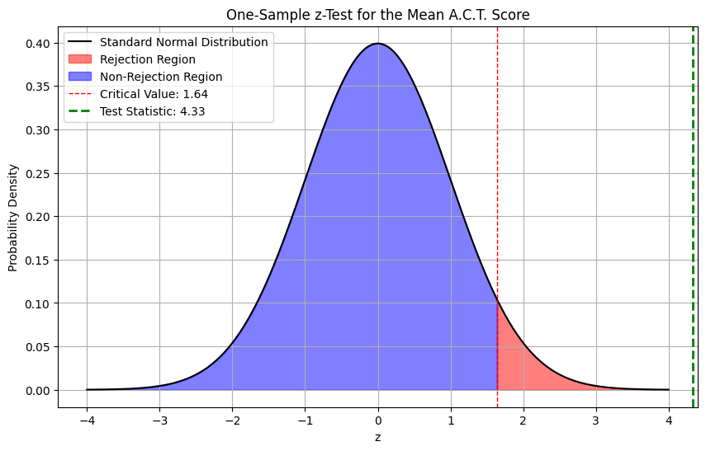**Curve**

**Conclusion**

Since the calculated z-value (4.33) is greater than the critical value (1.645), we reject the null hypothesis. There is sufficient evidence at the 5% significance level to conclude that the mean A.C.T. score attained by two-year college students is greater than 22.

Problem 2:

The secretary of an association of professional landscape gardeners claims that the average cost of services to customers is $90 per month. Feeling that this figure is too high, we question a random sample of 14 customers. Our sample yields a mean cost of $85 and a standard deviation of $10. Test at the 0.10 significance level. Assume that such costs are normally distributed.

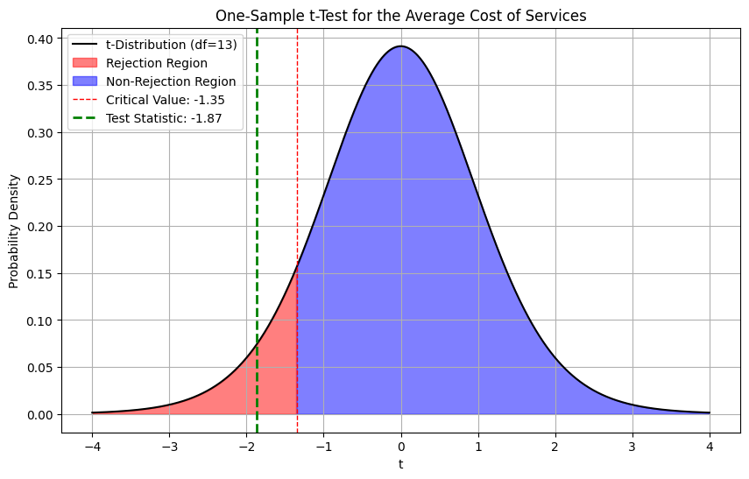

**Curve**

**Conclusion**

Since the calculated t-value (-1.87) is less than the critical value (-1.350), we reject the null hypothesis. There is sufficient evidence at the 10% significance level to conclude that the average cost of services to customers is less than $90 per month.